Assessment Schedule – 2014
Physics: Demonstrate understanding of mechanics (91171)
NØ | N1 | N2 | A3 | A4 | M5 | M6 | E7 | E8
No response; no relevant evidence. | 1a | 2a | 3a | 4a | 2m + 1a | 2m + 2a | 2m + 1e | 1e + 2m + 1a
Other combinations are also possible. However, for M5 or M6 at least one Merit question needs to be correct. For E7 or E8 at least one Excellence needs to be correct.
Evidence Statement
Question |  | Achievement | Merit | Excellence
ONE  (a) | 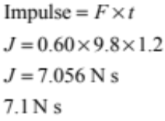 | Correct mathematical solution.
(b) | No, momentum is conserved only if there is no net outside force  Gravity (/air resistance) provides a net outside force. | Correct statement that momentum is not conserved. | Provides reason for statement:  EITHER momentum is not conserved when there is a net external force.  OR  Gravity ( / air resistance) provides a net external force
(c) | v_{v} = 0 because downward acceleration / force of gravity has slowed the ball to a stop  v_{H} = 12 m s^{–1} (V_{H} is constant) because there is no horizontal force / gravity does not affect horizontal motion | EITHER  BOTH component values correct.  OR  ONE component value and ONE explanation correct. | BOTH component values and BOTH explanations correct
(d) | 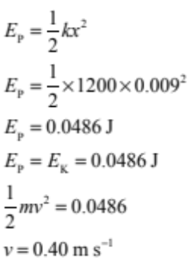  (Total) energy is conserved / elastic potential energy is converted into kinetic energy/no energy is lost from the system. | EITHER  ONE correct mathematical step.  OR  Correct assumption statement | EITHER  TWO correct mathematical steps.  OR  ONE correct mathematical step AND correct assumption statement. | TWO correct mathematical steps.  AND  Correct assumption statement.

Question |  | Achievement | Merit | Excellence
TWO  (a) | 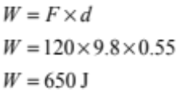 | Correct mathematical solution.
(b) | See Diagram in Appendix 1  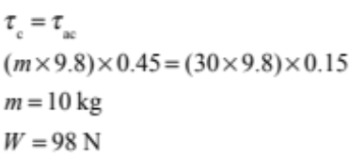 | Correct labelled diagram OR correct mathematical solution:  (Either m = 10 kg OR W = 98 N as long as unit is correct.) | Correct labelled diagram AND correct mathematical solution.
(c) | See Diagram in Appendix 2.  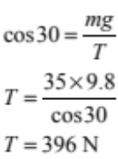 | Correct forces – may gain credit from either diagram.  (Note that the question does not require labels.)  OR  Correct mathematical solution. | Correct forces on either diagram AND correct mathematical solution.
(d) | - When he punches the bag, the stopping time is short/with a padded glove, the stopping time of his fist is longer.  - Impulse = Force × time, so if the impulse is the same, the punch with the glove produces a smaller force.  - The speed is the same, so the assumption is that the mass of the glove does not significantly affect the momentum of the fist / Δp is constant. | Force is larger without the glove.  OR  Force is smaller with the glove.  OR  Impact time is shorter without the glove.  OR  Impact time is longer with the glove.  OR  Δp is constant. | Explanation linked to impulse:  EITHER  Shorter time without glove linked to larger force without glove.  OR  Longer time with glove linked to smaller force with glove. | Merit plus assumption explained.

THREE  (a) | 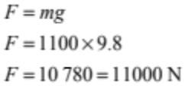 | Correct mathematical solution.
(b) | Even though the car is moving, the acceleration is zero because the net force / sum of the forces acting on the car is zero/forces are balanced. | ONE correct idea. | BOTH ideas linked.
(c) | 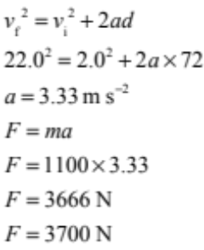 | Correct acceleration OR ONE error in calculation. | Correct acceleration and force.
(d) | Before she reaches the ice, there is a net friction force towards the centre of the curve. This causes the car to accelerate towards the center without changing speed / provides a centripetal force allowing the car to move in a circular path.  (After she reaches the ice, there is no longer any friction.) The net force on the car is zero, so it will keep travelling at constant speed at a tangent to the curve/in a straight line. | ONE correct idea – may be represented on the diagram. | TWO correct ideas. | ALL ideas clearly linked.

FOUR  (a) | 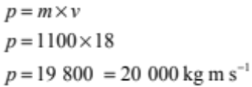 | Correct mathematical solution AND unit (accept Ns as alternative unit).
(b) | 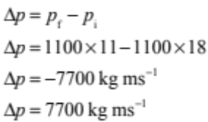  in the opposite direction to the direction of motion/backwards / negative sign. | Correct size or direction. | Correct size AND direction.
(c) | The total energy is conserved / transformed into other form(s).  Some of the car’s KE is converted to thermal energy (heat).  OR friction force does work on the car to reduce KE. | Recognition that total energy is conserved or transformed.  OR  Some kinetic energy converted to thermal or heat energy. | Recognition that total energy is conserved or transformed.  AND  Some kinetic energy converted to thermal or heat energy.
(d) | 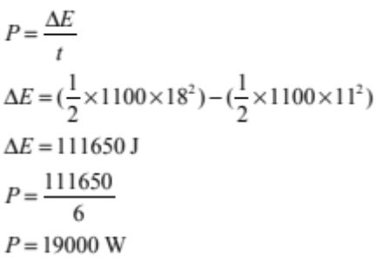  Alternative solution:  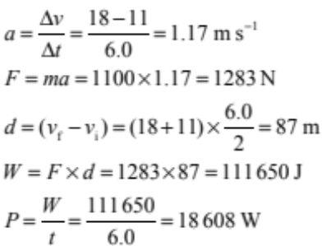 | Correct calculation of KE.  First 2 steps correct. | Correct calculation of change in KE.  Calculation of d and W. | Correct mathematical solution.  Correct solution.

Appendix 1 – Question Two (b)
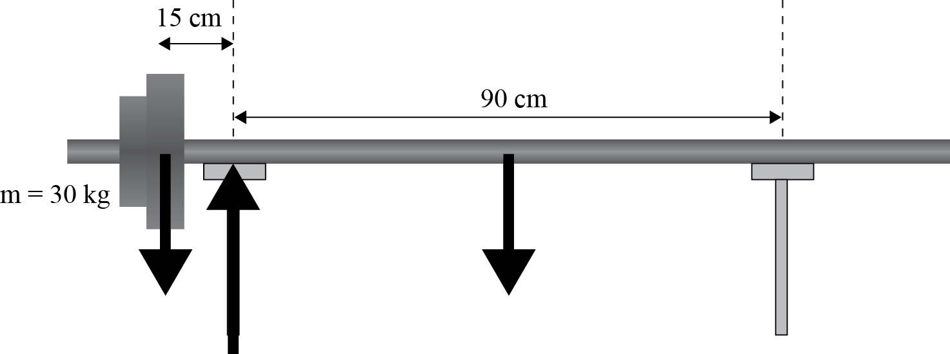

Appendix 2 – Question Two (c)
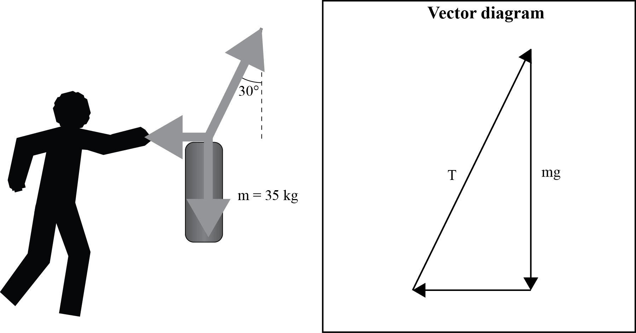

Cut Scores
 | Not Achieved | Achievement | Achievement with Merit | Achievement with Excellence
Score range | 0 – 8 | 9 – 16 | 17 – 24 | 25 – 32

